MOUNT ALVERNIA HIGH SCHOOL
ELECTRONIC DOCUMENT PREPARATION AND MANAGEMENT
EDPM ASSIGNMENT # 2 – RESEARCH - EMAIL
CASE
A new joint report by two United Nations agencies says overweight and obesity is on the rise throughout Latin America and the Caribbean, affecting every country, except Haiti. As the president of the Students’ Council body, you are ask to conduct a research on obesity to sensitize the students at your school about the negative impact of obesity on human’s health.
Your task is to obtain and summarize the information, prepare it for dissemination via e-mail, and state all sources in an appropriate bibliography.
DO NOT COPY AND PASTE ANY INFORMATION/CHARTS FROM WEBSITES, YOU WILL BE PENALIZED.
GUIDELINES
- Provide: Title and Cover pages
- Provide a brief ‘Description of Components’ of the SBA
- Provide a Table of Contents
COMPONENTS OF THE RESEARCH

- Definition/explanation of what is obesity and overweight and how overweight and obesity is determined.
- Explain what is meant by Body Max Index and insert a BMI chart to support your explanation
- Insert a table comparing weight categories, with their Body Max Index Class and with the equivalent weight of a person at any height of your choice. See example chart below. Include an introductory paragraph before the table.
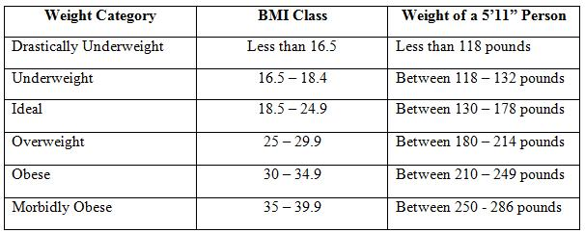
- Insert a pie column chart (on the same page with the table) comparing the percentage obesity among male and female adolescents, ages 10-18, in at least seven (7) Caribbean countries including Jamaica. Briefly explain the data being represented in the chart.
- Describe the major contributing factors to childhood obesity.
- List any TEN complications that may develop as a result of overweight and obesity.
- Discuss different media that will be used to inform the public. (Example: TV, radio, flyers, etc or a combination. Give reasons why you have selected each media to be used.
- Utilize Footnotes/Endnotes (two to be used in total; either one of each, or two of one)
- Utilize line ending hyphenation (at least twice)
- Provide a bibliography, using the APA format. You include at least THREE reference, including references from a book, newspaper and Internet sources.
- Print ‘Print screen or screen shot’ of a least two web pages used (Place on separate pages)
- In an e-mail, attach the research paper and the web links used.
- ‘Print screen or screen shot’ the email page, showing:
  - The two attachments (the research document and the web links)
  - Multiple recipients addressed inserted in the ‘To, Cc and Bcc’ sections.
ASSIGNMENT 2 CONT’D

Send To: tutorbrown7@gmail.com
Cc: mahsbusiness101@gmail.com + one other email address [no student doing EDPM
Bcc: 2 other persons, not including students who do EDPM at MAHS or any other school.
  - Brief message in the body of the e-mail.
17. Once you have screenshot the email page, insert the screenshots at the end of your research document.
18. Email the document by May 30, 2017 for electronic marking.

ADDITIONAL REQUIREMENTS

- Use a simple cover page; No borders, elaborate font and font size.
- Use Times New Roman, size 12 for the body of text
- Use Times New Roman, Size 14 for all headings, you may use all caps or initial caps
- Use appropriate line spacing, TLS after heading and between paragraphs; DLS between the lines in a paragraph.
- Use appropriate images; Use footnotes or endnotes meaningfully

